FRAUDULENT TRANSACTION DETECTION IN BANKING DATA USING MACHINE LEARNING
Project Report Submitted to the
[UNIVERSITY NAME]
In partial fulfillment of the requirement for the award of the degree of
[DEGREE NAME]
SUBMITTED BY
[STUDENT NAME] (Reg.No: [REGISTER NUMBER])
[ COLLEGE LOGO ]
UNDER THE GUIDANCE OF
[GUIDE NAME AND QUALIFICATIONS]
[GUIDE DESIGNATION]
DEPARTMENT OF [DEPARTMENT NAME]
[COLLEGE NAME]
[PLACE]
[ACADEMIC YEAR]
[COLLEGE NAME]
[PLACE]
[ COLLEGE LOGO ]
DEPARTMENT OF [DEPARTMENT NAME]
BONAFIDE CERTIFICATE
Certified that this project report “FRAUDULENT TRANSACTION DETECTION IN BANKING DATA USING MACHINE LEARNING” is the bonafide work of [STUDENT NAME] ([REGISTER NUMBER]) in [DEGREE NAME] who carried out the project work under my supervision.
Internal Guide Head of the Department
[GUIDE NAME] [HOD NAME]
Submitted for the viva-voce held at [COLLEGE NAME], [PLACE] on ____________
INTERNAL EXAMINER EXTERNAL EXAMINER
DECLARATION
I hereby declare that this project work entitled “FRAUDULENT TRANSACTION DETECTION IN BANKING DATA USING MACHINE LEARNING” is a record of original work done by me under the guidance of [GUIDE NAME AND QUALIFICATIONS], Department of [DEPARTMENT NAME], [COLLEGE NAME] and this project work has not formed the basis for the award of any degree or similar to candidate in any university.
[STUDENT NAME] ([REGISTER NUMBER])
Place:
Date:
ACKNOWLEDGEMENT
I praise GOD almighty for his blessings and grace showered upon me during my project work and for helping me to finish this project in a successful way. My sincere efforts have made me accomplish the task of completing this project.
I express my heartfelt thanks to our beloved Principal [PRINCIPAL NAME AND QUALIFICATIONS] for giving me an opportunity to undergo this project work.
I extend my profound gratitude to [HOD NAME AND QUALIFICATIONS], Head of the Department, Department of [DEPARTMENT NAME], [COLLEGE NAME], for giving me an opportunity to undergo this project work and for the timely help.
I express my deep sense of gratitude to my guide [GUIDE NAME AND QUALIFICATIONS], [GUIDE DESIGNATION], Department of [DEPARTMENT NAME], [COLLEGE NAME], for the guidance and supervision throughout the period of my project work.
I express my high thankfulness to my parents and friends for their help and encouragement throughout the successful completion of my project work.
INDEX
S.NO | CONTENTS | PAGE NO
1. | INTRODUCTION | 1-2
 | 1.1 About the Project | 1
 | 1.2 Project Description | 1
 | 1.3 Objectives | 2
 | 1.4 Scope of the Project | 2
2. | SYSTEM ANALYSIS | 3-4
 | 2.1 Feasibility Study | 3
 | 2.2 Existing System | 3
 | 2.3 Disadvantages of Existing System | 4
 | 2.4 Proposed System | 4
 | 2.5 Advantages of Proposed System | 4
3. | SYSTEM ENVIRONMENT | 5-7
 | 3.1 Hardware Requirements | 5
 | 3.2 Software Requirements | 5
 | 3.3 Software Specifications | 5
4. | SYSTEM DESIGN | 8-15
 | 4.1 Input Design | 8
 | 4.2 Output Design | 8
 | 4.3 System Architecture | 9
 | 4.4 Data Flow Diagram | 10
 | 4.5 Data Model | 11
 | 4.6 System Workflow | 13
5. | SYSTEM SPECIFICATION | 16-17
 | 5.1 Modules | 16
6. | SYSTEM IMPLEMENTATION | 18-22
 | 6.1 Implementation Overview | 18
 | 6.2 Model Training | 18
 | 6.3 Data Preprocessing | 19
 | 6.4 Logistic Regression Prediction | 20
 | 6.5 API Implementation | 20
 | 6.6 Transaction Logging | 21
 | 6.7 Frontend Integration | 21
 | 6.8 Execution Procedure | 21
7. | SYSTEM TESTING | 23-26
 | 7.1 Testing Objectives | 23
 | 7.2 Unit Testing | 23
 | 7.3 Integration Testing | 23
 | 7.4 Functional Testing | 23
 | 7.5 Performance Testing | 23
 | 7.6 User Acceptance Testing | 24
 | 7.7 Test Cases | 24
 | 7.8 Test Results | 25
8. | CONCLUSION | 27
9. | FUTURE ENHANCEMENT | 28
10. | BIBLIOGRAPHY | 29
11. | APPENDIX | 30-38
 | 11.1 Screenshots | 30
 | 11.2 Source Code | 34
 | 11.3 Project File Structure | 38

1. INTRODUCTION

1.1 About the Project
“Fraudulent Transaction Detection in Banking Data Using Machine Learning” is a software application that examines the details of a banking transaction and predicts whether the transaction is fraudulent or legitimate. The prediction is made by a supervised Machine Learning model, Logistic Regression, which has been trained to recognise patterns that separate fraudulent transactions from legitimate ones. Along with the classification, the system reports the fraud probability produced by the model and records every predicted transaction in a transaction log that can be viewed later.
Banking fraud is the use of deceptive or unauthorised transactions to obtain money or assets from customers or from a bank. As banking has moved to online and card-based channels, the number of transactions has grown far beyond what a human reviewer can check one by one. Fraud detection is therefore the process of automatically identifying suspicious transactions so that they can be blocked, verified or investigated before they cause a financial loss. Detecting fraud early protects customers’ money, reduces the bank’s losses and maintains trust in the banking system.
The application is implemented with a Python back end built on the FastAPI framework. The back end loads a trained Logistic Regression model and a StandardScaler from Joblib files, accepts transaction details through a JSON API, and returns the prediction. The application is accessed through a web interface at http://localhost:3000. The source code of that web interface was not part of the project files supplied for this documentation; therefore, this report describes the front end only as far as it can be established from the back end code (see Section 6.7).
Important note on data: the model in this project is trained on synthetic (artificially generated) transaction data that is created inside the training program. No real banking dataset is used. The project is therefore a demonstration of the complete fraud-detection workflow and should not be regarded as a production banking system.

1.2 Project Description
The goal of this project is to demonstrate how a Machine Learning model can be trained, stored and used inside a web service to flag potentially fraudulent banking transactions. The system accepts four transaction attributes, scales them, predicts the class of the transaction and stores the result. The main functions of the system are listed below.
- Transaction Input: accepts the transaction amount, the sender’s balance before the transaction, the sender’s balance after the transaction and an international-transaction flag.
- Data Preprocessing: converts the input into a table row and scales it with the saved StandardScaler so that it has the same scale as the training data.
- Fraud Prediction: uses the trained Logistic Regression model to classify the transaction as fraudulent (1) or legitimate (0).
- Fraud Probability: returns the probability that the transaction belongs to the fraudulent class.
- Transaction Logging: assigns a transaction ID and time stamp and stores the transaction with its prediction in a Joblib log file.
- Transaction Log Viewer: provides an API endpoint that returns all logged transactions, newest first, for display.
- Model Training: a separate training script generates synthetic data, trains and saves the model and scaler, and creates initial sample transactions.

1.3 Objectives
- To design a system that classifies a banking transaction as fraudulent or legitimate using Machine Learning.
- To train a Logistic Regression classifier and to save the trained model and the feature scaler for repeated use.
- To provide a REST API through which any client application can request a fraud prediction and obtain the fraud probability.
- To maintain a transaction log so that predicted transactions can be reviewed later.
- To demonstrate the end-to-end workflow of data preparation, model training, model persistence and prediction in a simple, understandable form suitable for a college major project.

1.4 Scope of the Project
The scope of the project covers the development of the back end fraud-prediction service, the training script, the storage of the trained artefacts and the transaction log, and the connection with a web interface running at http://localhost:3000. The project uses four input features only (amount, oldbalanceOrg, newbalanceOrig and is_international) and one algorithm (Logistic Regression).
The following are outside the present scope, because they are not implemented in the supplied project files: authentication and user accounts, a relational database, use of real banking data, real-time integration with a bank’s core system, automatic blocking of transactions, and model retraining from the logged transactions. These points are discussed further in Chapter 9 (Future Enhancement).

2. SYSTEM ANALYSIS

2.1 FEASIBILITY STUDY
A feasibility study is carried out to find out whether a proposed system can be developed with the available technology, within the available cost, and whether it will be accepted by its users. It is done at an early stage so that a decision can be taken on whether to go ahead with a more detailed analysis. The following aspects were considered for this project.
- Technical Feasibility
- Economic Feasibility
- Operational / Behavioral Feasibility

2.1.1 Technical Feasibility
Technical feasibility deals with the hardware and software required by the system. The project uses Python and freely available open-source libraries (FastAPI, Uvicorn, pandas, NumPy, scikit-learn and Joblib). The Logistic Regression model is computationally light: training on 5,000 synthetic records completes within a few seconds on an ordinary computer, and a single prediction takes only a few milliseconds. Therefore, no special hardware such as a GPU is needed.
- The software runs on any operating system that supports Python (Windows, Linux or macOS).
- An ordinary personal computer is sufficient as the server.
- The system can be expanded by adding more features, a database or a different model without changing the API structure.

2.1.2 Economic Feasibility
Economic feasibility compares the cost of developing and operating the system with the benefits obtained. All the software used in the project is open source and free of licence cost, and the system runs on existing hardware. The only significant cost is development time. In return, the system automates the first level of screening of transactions, which reduces the effort of manual checking. The project is therefore economically feasible.

2.1.3 Operational / Behavioral Feasibility
Operational feasibility examines how the system will work when it is installed and whether its users will accept it. The user only has to enter four values for a transaction and read the result, so very little training is needed. The API accepts and returns JSON, which makes it easy to connect to a web page or to another application. The system is therefore operationally feasible.

2.2 Existing System
In a conventional set-up, suspicious transactions are identified mainly by manual review of statements and by fixed rules, for example blocking every transaction above a certain amount. Such an approach depends on human effort and on rules that must be written and updated by hand. The drawbacks of this approach are listed in Section 2.3.

2.3 Disadvantages of Existing System
- Manual checking is slow and cannot keep up with a large number of transactions.
- Fixed rules are rigid: they either flag too many genuine transactions or miss fraud that does not match the rule.
- The rules do not learn from data and must be changed manually when fraud patterns change.
- There is no probability or score that tells the reviewer how likely it is that a transaction is fraudulent.
- There is often no organised log that can be viewed quickly for review.

2.4 Proposed System
The proposed system replaces manual screening with a trained Machine Learning model. The transaction details are sent to a FastAPI service; the service scales the values, applies the Logistic Regression model and returns the class (fraudulent or legitimate) together with the fraud probability. Every predicted transaction is given an ID and a time stamp and is appended to a transaction log, which can be retrieved through a second API endpoint and displayed in a log viewer.

2.5 Advantages of Proposed System
- Predictions are produced automatically within milliseconds.
- The fraud probability gives a score in addition to the yes/no decision.
- The model is learned from data instead of being written as fixed rules, and it can be retrained by running the training script again.
- Transactions are logged with an ID and a time stamp for later review.
- The API can be used by any client application, and the technology is open source and low cost.
- The Logistic Regression model is simple and its behaviour (coefficients) can be inspected and explained.

3. SYSTEM ENVIRONMENT

3.1 HARDWARE REQUIREMENTS
The hardware configuration of the machine on which the project was developed is not available in the provided project files. The following is the minimum configuration recommended for running the project; it may be replaced by the actual development configuration.
Processor : Intel Core i3 or equivalent (recommended minimum)
RAM capacity : 4 GB (recommended minimum)
Hard disk drive : 1 GB of free space is sufficient for the project files
Keyboard : Standard keyboard
Mouse : Optical mouse
Monitor : Colour monitor

3.2 SOFTWARE REQUIREMENTS
The software used for the development and running of the project is:
Operating System : Windows / Linux / macOS (any system that supports Python)
Programming language : Python 3
Back end framework : FastAPI, served with Uvicorn (port 8000)
Machine Learning : scikit-learn (Logistic Regression, StandardScaler)
Data handling : pandas, NumPy
Model storage : Joblib files (.joblib)
Front end : Web interface at http://localhost:3000 (technology not available in the provided project files)
The file requirements.txt lists fastapi, uvicorn, scikit-learn, pandas and joblib without version numbers. NumPy is imported by the training script and is installed automatically as a dependency of pandas and scikit-learn. On loading, the supplied model.joblib and scaler.joblib were found to have been saved with scikit-learn 1.9.1, so the same version is recommended when the project is run again.

3.3 SOFTWARE SPECIFICATIONS

3.3.1 Python
Python is a high-level, general-purpose programming language known for its clear syntax and its very large collection of libraries. It is the most widely used language for Machine Learning and data analysis. In this project Python is used for the API, the data generation, the model training and the prediction. The standard library modules random, datetime and os are also used for generating transaction IDs and time stamps and for checking whether files exist.

3.3.2 FastAPI
FastAPI is a modern web framework for building APIs with Python. It is based on Python type hints and on the Pydantic library, which automatically validates the data received in a request. FastAPI also generates interactive API documentation automatically. In this project FastAPI defines two endpoints, GET /api/transactions and POST /api/predict, and its CORSMiddleware allows a web page running on a different address (the front end at port 3000) to call the API. The application is run with Uvicorn, an ASGI web server. The request body is described by a Pydantic model named Transaction.

3.3.3 Pandas
Pandas is a Python library for handling tabular data. Its main structure, the DataFrame, stores data in rows and columns with named columns. In this project pandas is used in the training script to store the generated dataset and in the API to convert the incoming transaction into a one-row DataFrame whose column names match the features used in training.

3.3.4 NumPy
NumPy is the basic library for numerical computing in Python. It provides fast arrays and mathematical and random-number functions. In this project NumPy is used in train_model.py to generate the synthetic data: exponential and uniform random numbers, random choices and the logistic (sigmoid) function.

3.3.5 Scikit-learn
Scikit-learn is an open-source Machine Learning library for Python that provides tools for classification, regression, clustering and data preprocessing with a consistent interface (fit, transform, predict). This project uses two of its components: LogisticRegression for classification and StandardScaler for feature scaling. The function train_test_split is imported in the training script but is not used in the supplied code.

3.3.6 Joblib
Joblib is a Python library for saving (serialising) and loading Python objects efficiently, and it is commonly used to store trained scikit-learn models. In this project joblib.dump() saves the trained model (model.joblib), the fitted scaler (scaler.joblib) and the list of transaction records (mock_logs.joblib), and joblib.load() reads them back when the API needs them. Joblib files should only be loaded from trusted sources because they are based on Python’s pickle format.

3.3.7 Logistic Regression
Logistic Regression is a supervised learning algorithm used for classification. Although the name contains “regression”, it predicts the probability that an example belongs to a class. It first computes a weighted sum of the input features, z = b + w1·x1 + w2·x2 + … + wn·xn, where b is the intercept and w1 … wn are the weights (coefficients) learned during training. The value z is then passed through the sigmoid function, p = 1 / (1 + e^(−z)), which converts any number into a probability between 0 and 1. For a two-class problem the transaction is classified as fraudulent (class 1) when p is at least 0.5, and as legitimate (class 0) otherwise.
In this project the model is created as LogisticRegression(class_weight=’balanced’). The option class_weight=’balanced’ gives each class a weight inversely proportional to how often it appears in the training data, so that the less frequent class is not ignored. The remaining parameters are the scikit-learn defaults (for example C = 1.0 and the lbfgs solver).

3.3.8 StandardScaler
StandardScaler is a preprocessing tool that standardises each feature by subtracting the mean and dividing by the standard deviation of that feature: z = (x − mean) / standard deviation. The feature values in this project have very different ranges (the transaction amount is in hundreds, the balances are in tens of thousands, and the international flag is 0 or 1). Scaling brings them to a comparable range and helps the optimisation of Logistic Regression. The scaler is fitted once on the training data and then saved, so that every new transaction is scaled with exactly the same mean and standard deviation values.

4. SYSTEM DESIGN

4.1 INPUT DESIGN
Input design converts the user’s data into a form that the system can process. The goal is to make data entry easy, logical and free from errors, and to ask the user for the minimum data required. The system receives one transaction at a time as a JSON request body sent to the endpoint POST /api/predict. The body is described by the Pydantic model Transaction, which contains the four fields shown in Table 1. FastAPI checks that the required fields are present and that their values can be converted to the declared data types before the prediction code is executed.
Table 1: Input fields of the Transaction model
Field Name | Type | Description | Example
amount | float | Value of the transaction | 2500.0
oldbalanceOrg | float | Balance of the sender’s account before the transaction | 30000.0
newbalanceOrig | float | Balance of the sender’s account after the transaction | 27500.0
is_international | int | International transaction flag: 1 = international, 0 = domestic (by the convention used in the training data) | 0
All four fields are mandatory. The supplied code checks only the data type of each field; it does not check that the amount is positive, that is_international is only 0 or 1, or that the new balance equals the old balance minus the amount. These are noted as limitations in Chapter 8.

4.2 OUTPUT DESIGN
Output design describes how the results are presented to the user. Good output should be clear, accurate and helpful in decision-making. The system produces two kinds of output, both in JSON format so that a web interface can display them. The response of POST /api/predict is described in Table 2.
Table 2: Response fields of POST /api/predict
Field Name | Type | Description
transaction_id | string | Generated ID of the form TXN followed by a random five-digit number, e.g. TXN65504
is_fraud | integer | 1 = fraudulent transaction, 0 = legitimate transaction
probability | float | Probability (0 to 1) that the transaction is fraudulent, from predict_proba()
The response of GET /api/transactions is a JSON object with one key, transactions, whose value is the list of logged transaction records sorted with the newest time stamp first. Each record contains the fields listed in Table 3 (Section 4.5). If the log file does not exist, an empty list is returned. The results are shown to the user on the front end (Transaction Log Viewer and prediction result screens); the screenshots are placed in Appendix 11.1.

4.3 SYSTEM ARCHITECTURE
The system follows a simple layered architecture, shown in Figure 1. The client layer is the web interface running at http://localhost:3000. It communicates over HTTP with the FastAPI application (running with Uvicorn on port 8000), which contains the CORS middleware, the Pydantic input model and the two endpoints. For a prediction, the application passes the input to the Machine Learning layer, where the data is placed in a pandas DataFrame, scaled by the StandardScaler and classified by the Logistic Regression model. The model and scaler are loaded from model.joblib and scaler.joblib. The transaction log is stored in mock_logs.joblib. The three Joblib files are created beforehand by the offline training script train_model.py.
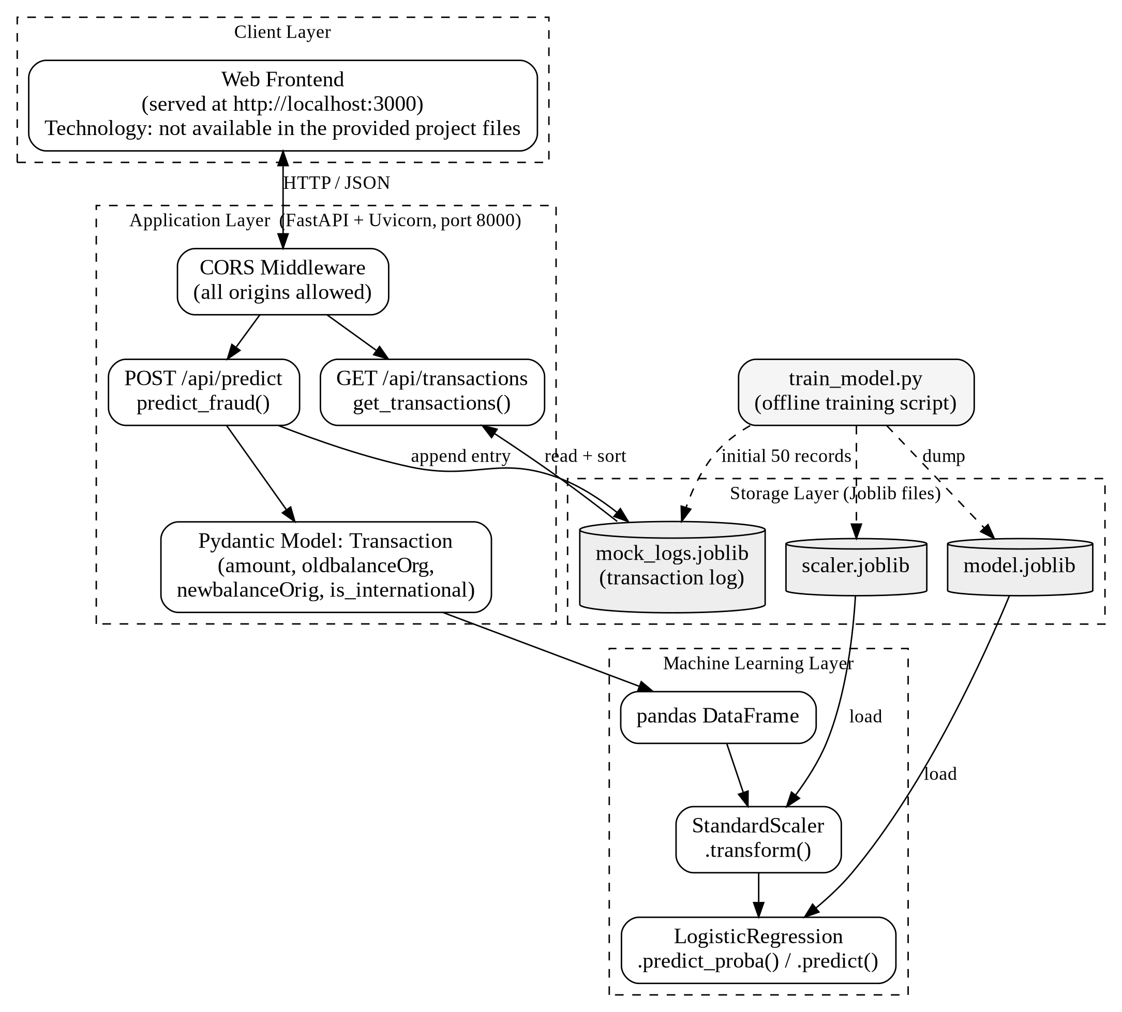
Figure 1: System Architecture

4.4 DATA FLOW DIAGRAM
A Data Flow Diagram (DFD) shows how data moves through a system, the processes that transform it and the places where it is stored. It is a structured analysis tool that describes the system at a logical level without showing physical implementation. The following four symbols are used in the diagrams of this report.
- External entity (rectangle): a source or destination of data, here the user or bank analyst.
- Data flow (arrow): the movement of data between entities, processes and stores.
- Process (circle): an activity that transforms data.
- Data store (open rectangle): a place where data is kept, here the Joblib files.

Level 0 DFD (Context Diagram)
The Level 0 DFD represents the whole system as a single process. The user sends transaction details and log requests to the system, and receives the prediction result with the fraud probability and transaction ID, and the transaction log list.
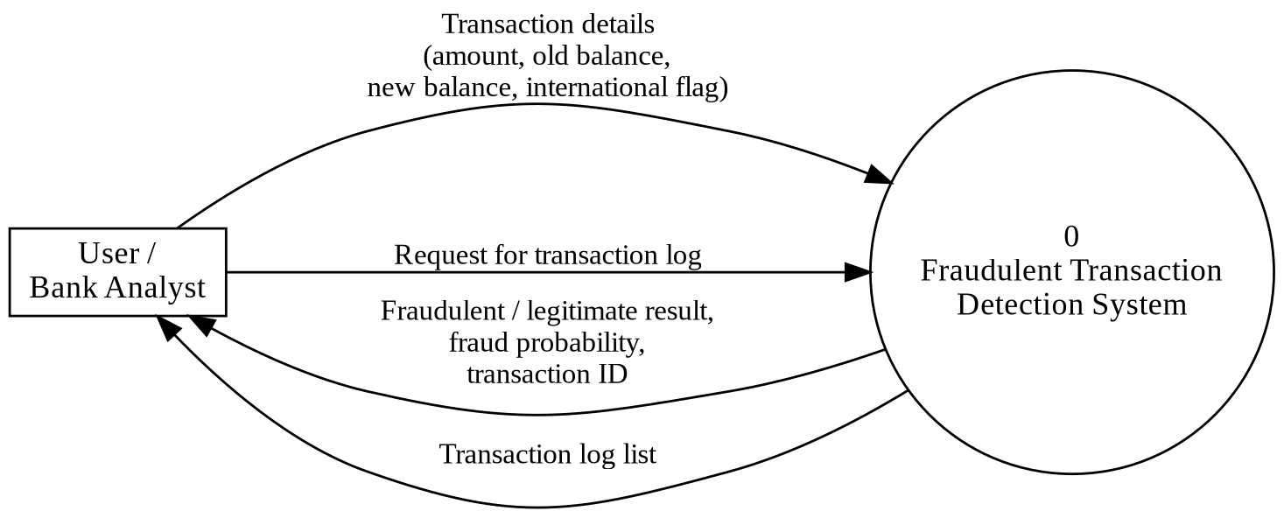
Figure 2: Level 0 Data Flow Diagram

Level 1 DFD
The Level 1 DFD divides the system into five processes and three data stores. The user’s transaction input is validated (1.0), scaled with the stored scaler (2.0), classified with the stored model (3.0) and then written to the transaction log (4.0). The result is returned to the user. In a separate flow, the retrieve-log process (5.0) reads the stored entries and returns them sorted newest first.
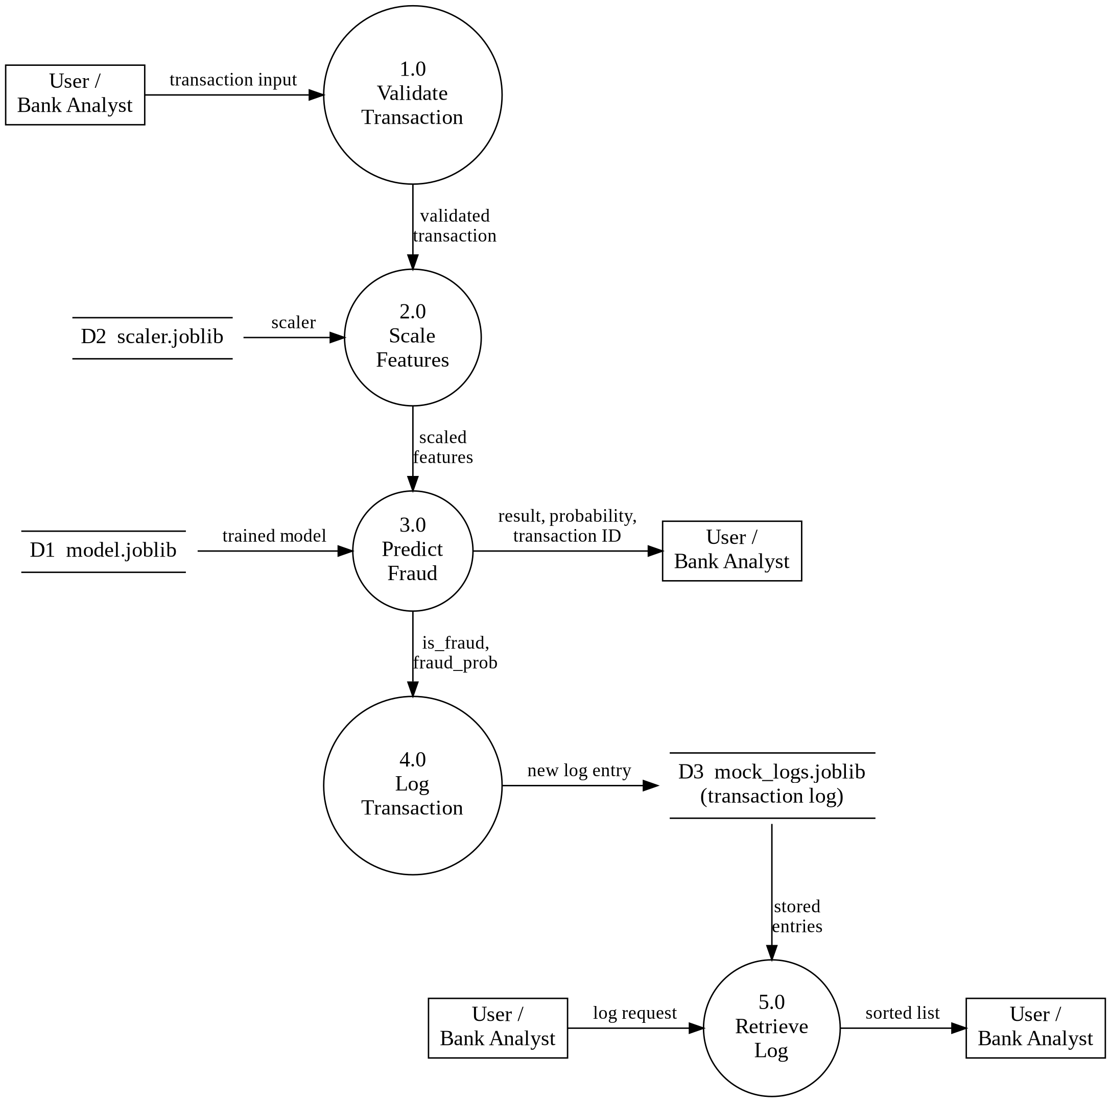
Figure 3: Level 1 Data Flow Diagram

4.5 DATA MODEL
An Entity-Relationship (ER) diagram describes the tables of a relational database and the relationships between them. This project does not use a relational database: no tables, primary keys or foreign keys exist. The transaction log is a Python list of dictionaries stored in a Joblib file (mock_logs.joblib), and the trained model and scaler are stored as Joblib files. An ER diagram is therefore not technically appropriate, and a logical data model of the data actually handled by the system is given instead in Figure 4.
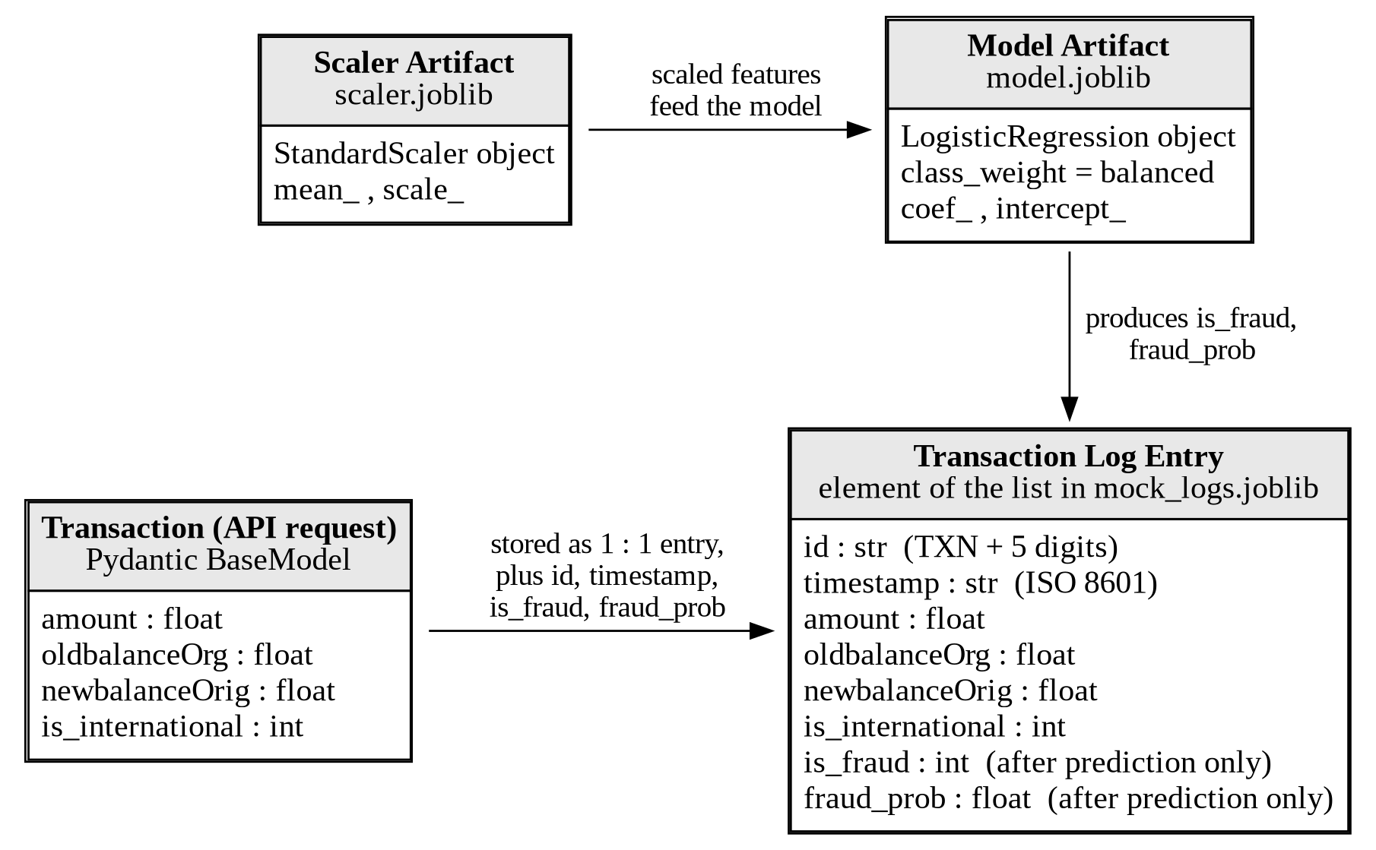
Figure 4: Logical Data Model
Table 3: Fields of a transaction log entry (element of the list in mock_logs.joblib)
Field Name | Type | Size
id | string (TXN + 5 digits) | 8 characters
timestamp | string (ISO 8601 date-time) | -
amount | float | -
oldbalanceOrg | float | -
newbalanceOrig | float | -
is_international | int (0 or 1) | -
is_fraud | int (0 or 1) – present only in entries created by a prediction | -
fraud_prob | float – present only in entries created by a prediction | -
The 50 sample transactions created by train_model.py contain only the first six fields. The fields is_fraud and fraud_prob are added by the API when a transaction is predicted and logged. In the supplied mock_logs.joblib, 50 entries are such initial records and one entry contains the two prediction fields.
Table 4: Data files used by the system
File | Content | Created by | Used by
model.joblib | Trained LogisticRegression object | train_model.py | POST /api/predict
scaler.joblib | Fitted StandardScaler object | train_model.py | POST /api/predict
mock_logs.joblib | List of transaction dictionaries | train_model.py (initial 50); app.py (new entries) | Both endpoints

4.6 SYSTEM WORKFLOW

Model training workflow
Figure 5 shows the workflow of train_model.py. The script generates 5,000 synthetic transactions, separates the features from the target, fits the scaler, trains the Logistic Regression model, prints the accuracy on the training data and saves the model and scaler. It then creates 50 sample transactions and saves them as the initial transaction log.
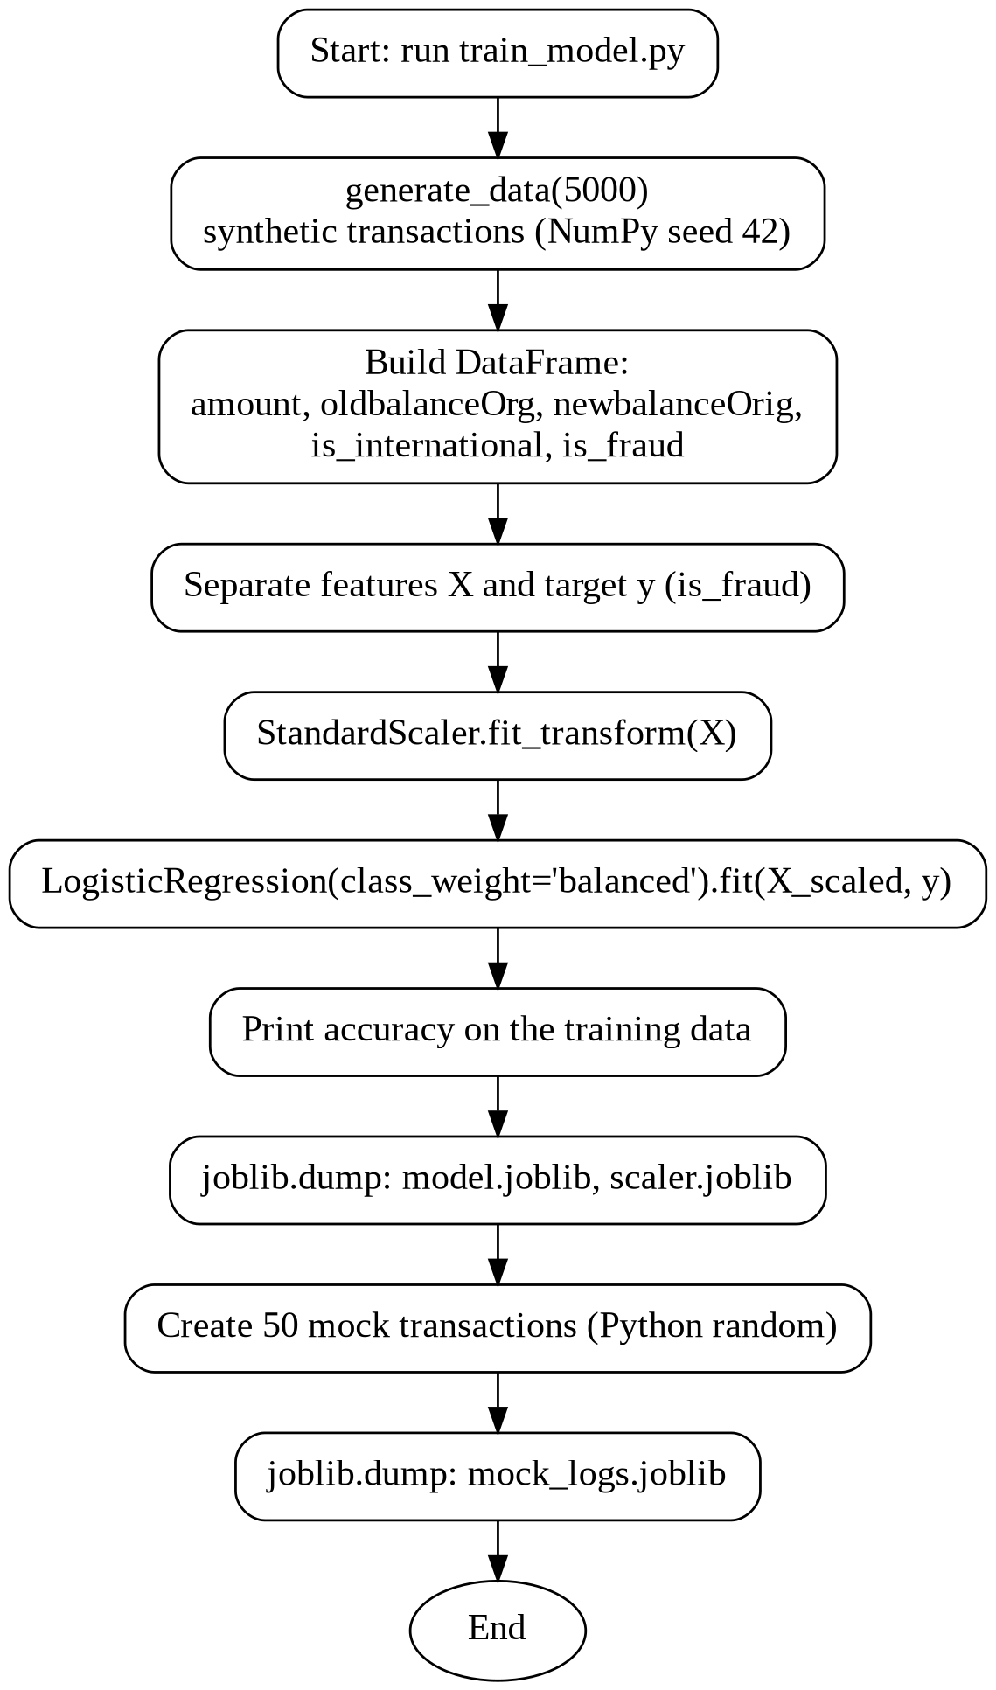
Figure 5: Machine Learning Workflow (Model Training)

Prediction workflow
Figure 6 is the flowchart of the prediction process implemented in app.py. If the model or scaler file is missing, the API returns an HTTP 500 error asking the user to run train_model.py first. Otherwise, the transaction is scaled, the probability and class are calculated, a transaction ID and time stamp are generated, the entry is appended to the log file and the result is returned.
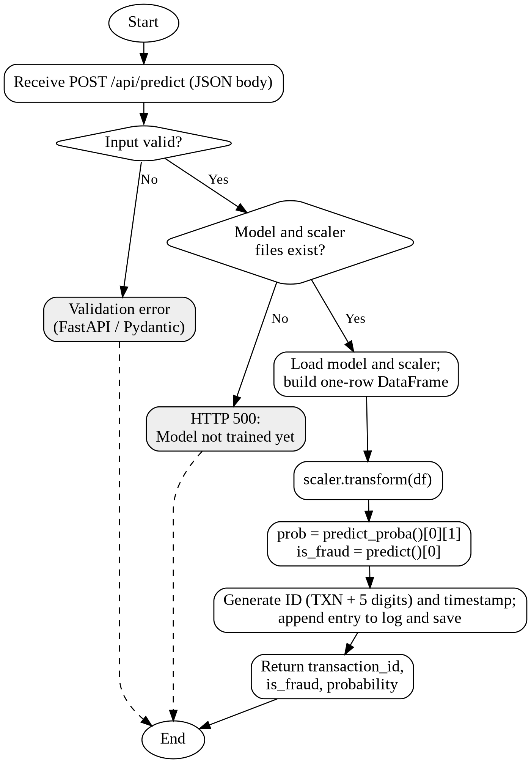
Figure 6: System Flowchart (Fraud Prediction)

Log viewing workflow
When the Transaction Log Viewer requests GET /api/transactions, the API checks whether mock_logs.joblib exists, loads the list, sorts it by time stamp in descending order and returns it as {"transactions": [...]}. If the file does not exist, {"transactions": []} is returned.

5. SYSTEM SPECIFICATION

5.1 MODULES
The system consists of the following modules. Each module corresponds to a part of the supplied source code (app.py and train_model.py).

5.1.1 Transaction Input Module
This module receives the transaction details from the client. It is implemented by the Pydantic class Transaction and the endpoint POST /api/predict. The four fields amount, oldbalanceOrg, newbalanceOrig and is_international are required, and their data types are validated automatically by FastAPI.

5.1.2 Data Preprocessing Module
This module prepares the input for the model. The validated values are placed in a one-row pandas DataFrame whose column names and order match the training features, and the DataFrame is transformed with the saved StandardScaler (scaler.transform). Using the same scaler as in training guarantees that the model sees data on the same scale.

5.1.3 Fraud Prediction Module
This module classifies the transaction. It loads the trained Logistic Regression model and calls predict() on the scaled data. The result is an integer: 1 for a fraudulent transaction and 0 for a legitimate transaction.

5.1.4 Transaction Log Module
This module keeps the record of transactions. After each prediction, it creates a log entry containing the transaction ID, time stamp, the four input values, the class and the probability, appends it to the list stored in mock_logs.joblib and saves the file. The endpoint GET /api/transactions returns the log sorted newest first, for display in the log viewer.

5.1.5 Fraud Probability Module
This module gives the confidence of the model. It calls predict_proba() and takes the probability of class 1 (fraudulent). The probability is returned in the response and stored in the log entry, so that a reviewer can see how strongly the model considers a transaction to be fraudulent.

5.1.6 Model Training Module
This module is the script train_model.py. It generates the synthetic dataset, fits the StandardScaler, trains the LogisticRegression model with class_weight=’balanced’, prints the accuracy on the training data and creates the initial sample transactions. It is run once, before the API is started, and again whenever the model has to be rebuilt.

5.1.7 Model and Scaler Storage Module
This module handles persistence. The trained model and the fitted scaler are written with joblib.dump() to model.joblib and scaler.joblib and are read with joblib.load() by the API. Storing them means the model does not have to be trained again each time the application starts.

6. SYSTEM IMPLEMENTATION

6.1 IMPLEMENTATION OVERVIEW
Implementation is the stage in which the design is converted into a working system. The project is implemented in Python and consists of two source files. The file train_model.py creates the synthetic data, trains the model and writes the three Joblib files. The file app.py is the FastAPI application that loads those files and serves the two endpoints. The complete source code is given in Appendix 11.2. The main steps of implementation were: (1) generation of the dataset, (2) scaling of the features, (3) training and saving of the model, (4) development of the prediction API, (5) development of the transaction log, and (6) connection of the API to the web interface.

6.2 MODEL TRAINING

Machine Learning approach
The project uses supervised learning. In supervised learning the algorithm is given examples in which the correct answer is already known (labelled data), and it learns a rule that maps the input features to the answer. Here the input features are the four transaction attributes and the answer, called the target variable, is is_fraud, where 1 means a fraudulent transaction and 0 means a legitimate transaction. Because the target has two classes, the task is a binary classification problem.

Dataset preparation (synthetic data)
No external banking dataset is used. The function generate_data() in train_model.py creates the data artificially, and train_and_save_model() calls it with n = 5000 records. The random generator is seeded with 42, so the same dataset is produced every time. The rules used to create the data are summarised in Table 5.
Table 5: Rules used to generate the synthetic training data
Column | How it is generated
amount | Exponential distribution with scale 500
oldbalanceOrg | Uniform random value between 0 and 100,000
newbalanceOrig | oldbalanceOrg − amount
is_international | Random choice of 0 or 1 with probabilities 0.9 and 0.1
is_fraud (target) | z = (amount − 500) / 500 + 2 × is_international; probability = 1 / (1 + e^(−z)); label = 1 if a random number is below the probability; label is forced to 0 when amount < 50
In this synthetic data, higher amounts and international transfers therefore have a higher chance of being labelled fraudulent. The label depends only on amount and is_international; the two balance columns are not used in the labelling rule. Re-generating the dataset with the supplied code gives 5,000 records, about 10.2% international transactions and about 47.9% records labelled fraudulent. Because the labels are produced by a formula and not observed from real banking activity, the fraud rate and the results shown in this report are properties of the demonstration data only.

Training
The features are separated from the target, the StandardScaler is fitted and applied, and the LogisticRegression model is trained with class_weight=’balanced’. The trained objects are then saved. The relevant code is given below.
def generate_data(n=1000):
np.random.seed(42)
amount = np.random.exponential(scale=500, size=n)
oldbalanceOrg = np.random.uniform(0, 100000, size=n)
newbalanceOrig = oldbalanceOrg - amount
is_international = np.random.choice([0, 1], size=n, p=[0.9, 0.1])
z = (amount - 500) / 500 + is_international * 2
prob = 1 / (1 + np.exp(-z))
is_fraud = (np.random.rand(n) < prob).astype(int)
is_fraud[amount < 50] = 0

scaler = StandardScaler()
X_scaled = scaler.fit_transform(X)
model = LogisticRegression(class_weight='balanced')
model.fit(X_scaled, y)
joblib.dump(model, 'model.joblib')
joblib.dump(scaler, 'scaler.joblib')
When train_model.py was run in the documentation environment, it printed “Accuracy: 0.6918” and produced the same model coefficients as the supplied model.joblib. This value is the accuracy on the same synthetic data that was used for training (the script does not split the data into training and test sets), so it must not be taken as a measure of performance on real banking transactions.

6.3 DATA PREPROCESSING
Preprocessing is done with StandardScaler. During training, fit_transform() calculates the mean and the standard deviation of each of the four features and scales the training data. The fitted scaler is saved. At prediction time, only transform() is called, using the saved values, so that new transactions are scaled exactly like the training data. The statistics stored in the supplied scaler.joblib are given in Table 6.
Table 6: Scaler statistics and learned model coefficients (from the supplied files)
Feature (in order) | Mean | Standard deviation | Coefficient
amount | 494.88 | 493.48 | 1.1697
oldbalanceOrg | 49,148.71 | 28,558.79 | 0.0044
newbalanceOrig | 48,653.83 | 28,570.43 | −0.0158
is_international | 0.1018 | 0.3024 | 0.4860
Intercept |  |  | 0.0952

6.4 LOGISTIC REGRESSION PREDICTION
For a new transaction, the API scales the four values and calls predict_proba() and predict(). The probability of the fraudulent class is p = 1 / (1 + e^(−z)), where z is the intercept plus the sum of each scaled feature multiplied by its coefficient (Table 6). The class is 1 when p is at least 0.5.
df = pd.DataFrame([{
'amount': transaction.amount,
'oldbalanceOrg': transaction.oldbalanceOrg,
'newbalanceOrig': transaction.newbalanceOrig,
'is_international': transaction.is_international
}])
df_scaled = scaler.transform(df)
prob = model.predict_proba(df_scaled)[0][1]
is_fraud = int(model.predict(df_scaled)[0])
Worked example. For amount = 3000, oldbalanceOrg = 50000, newbalanceOrig = 47000 and is_international = 1, the scaled values are 5.076, 0.030, −0.058 and 2.970. Then z = 0.0952 + 1.1697 × 5.076 + 0.0044 × 0.030 + (−0.0158) × (−0.058) + 0.4860 × 2.970 ≈ 7.478 and p = 1 / (1 + e^(−7.478)) ≈ 0.9994, which agrees with the probability returned by the model for this input (0.9994). The transaction is classified as fraudulent.
Since the amount and the international flag have the largest coefficients, these two features have the greatest influence on the prediction, which is consistent with the rule used to generate the synthetic labels.

6.5 API IMPLEMENTATION
The API is implemented in app.py with FastAPI. The application is titled “Fraud Detection API”. CORSMiddleware is added with allow_origins, allow_methods and allow_headers set to all values, so that the web interface running on another port can call the API. The two endpoints are summarised in Table 7.
Table 7: API endpoints implemented in app.py
Method and Path | Function | Purpose | Output
GET /api/transactions | get_transactions() | Return all logged transactions, sorted by time stamp (newest first) | {"transactions": [ ... ]}
POST /api/predict | predict_fraud() | Predict whether the submitted transaction is fraudulent, log it and return the result | {"transaction_id", "is_fraud", "probability"}
If model.joblib or scaler.joblib does not exist, POST /api/predict raises an HTTP 500 error with the message “Model not trained yet. Run train_model.py first.” The application can be started with python app.py, which runs Uvicorn on host 0.0.0.0 and port 8000.

6.6 TRANSACTION LOGGING
After the prediction, the API generates a transaction ID (TXN followed by a random number between 10000 and 99999) and the current time stamp in ISO format, builds the log entry, appends it to the list loaded from mock_logs.joblib and saves the list again. The initial content of the log consists of the 50 sample transactions created by train_model.py.
txn_id = f'TXN{random.randint(10000, 99999)}'
new_txn = {'id': txn_id,
'timestamp': datetime.datetime.now().isoformat(),
'amount': transaction.amount, ...
'is_fraud': is_fraud, 'fraud_prob': prob}
logs = joblib.load(logs_path) if os.path.exists(logs_path) else []
logs.append(new_txn)
joblib.dump(logs, logs_path)
Because the ID is chosen randomly and is not checked against existing IDs, two entries could in principle receive the same ID. The log is a single file that is fully read and rewritten for every prediction, which is adequate for a demonstration but not for many simultaneous users.

6.7 FRONTEND INTEGRATION
The application is used through a web interface at http://localhost:3000. The source code of this front end was not available in the provided project files, so the technology used and the exact screens are not documented here; the screens supplied as screenshots are shown in Appendix 11.1. The integration with the back end can be described from app.py: the front end runs on a different port (3000) from the API (8000), and the API therefore enables CORS for all origins. The front end sends the four transaction values as JSON to POST /api/predict, displays the returned class, probability and transaction ID, and calls GET /api/transactions to show the transaction log. Whether the interface actually performs each of these calls is to be verified against the front end code.

6.8 EXECUTION PROCEDURE
The project is executed with the following steps.
- Install Python 3 and open a terminal in the project folder.
- Install the required libraries: pip install -r requirements.txt.
- Train the model and create the data files: python train_model.py. This creates model.joblib, scaler.joblib and mock_logs.joblib. Running the script again overwrites all three files, including the transaction log.
- Start the API server: python app.py. The API listens on http://localhost:8000.
- Open the web interface at http://localhost:3000 (the command used to start the front end is not available in the provided project files).
- Enter the transaction details to obtain a prediction, and open the transaction log viewer to see the stored transactions.
FastAPI also provides interactive API documentation by default, normally at http://localhost:8000/docs, which can be used to test the endpoints without the front end.

7. SYSTEM TESTING
Software testing is an important element of software quality assurance and represents the final review of specification, design and coding. Testing is carried out by giving both correct and wrong information to the system and checking that it behaves as expected. In this chapter, only the results that could be verified are reported as Pass; results that could not be verified from the provided material are marked “To be verified”.

7.1 TESTING OBJECTIVES
- To check that the model and scaler files can be loaded and used correctly.
- To check that transactions are classified as fraudulent or legitimate in a sensible way and that the probability is returned.
- To check that transactions are logged and retrieved in the correct order.
- To identify weaknesses, such as missing input checks, so that they can be documented and improved.

7.2 UNIT TESTING
Unit testing checks each part of the program separately. The following units were tested by executing them directly in the documentation environment: the data generator and training function in train_model.py (test case TC-14), loading of the model and the scaler (TC-11, TC-12), the prediction steps of predict_fraud() – DataFrame creation, scaling, predict_proba() and predict() – (TC-04 to TC-10, TC-19) and the sorting logic of get_transactions() (TC-16).

7.3 INTEGRATION TESTING
Integration testing checks that the units work correctly when combined. The combination of the saved scaler and the saved model was tested by passing a raw transaction through the complete pipeline, and the presence of a prediction entry in the log file confirms that the prediction and the logging steps worked together (TC-15). The integration of the API with HTTP requests and of the API with the front end (TC-01 to TC-03, TC-13, TC-17, TC-18) could not be executed in the documentation environment and is marked “To be verified”.

7.4 FUNCTIONAL TESTING
Functional testing checks that each function of the system works according to its specification. The functions tested are: valid transaction input, invalid input, fraud prediction, legitimate prediction, international transaction handling, model and scaler availability, transaction log creation, transaction retrieval, API response and front end – back end communication. The test cases are given in Section 7.7.

7.5 PERFORMANCE TESTING
Performance testing evaluates the speed of the system. In the documentation environment, the complete prediction sequence of the API (loading model.joblib and scaler.joblib, creating the DataFrame, scaling, predict_proba() and predict()) was repeated 200 times and took about 10.5 milliseconds on average per prediction. This figure is only indicative because it was measured on a different computer from the project machine and excluded the network time and the writing of the log file. The measurement on the project machine, and the behaviour under many simultaneous requests, is to be verified.

7.6 USER ACCEPTANCE TESTING
User acceptance testing is carried out by the intended users to confirm that the system meets their needs. No user feedback or acceptance record is available in the provided project files, so this test is to be verified by demonstrating the running application to the project guide or to sample users and recording their feedback.

7.7 TEST CASES
Table 8 lists the test cases. For test cases TC-04 to TC-10 and TC-19 the “Actual Result” was obtained by executing the same steps as the function predict_fraud() (creating a one-row DataFrame with the four features, scaler.transform(), predict_proba() and predict()) with the supplied model.joblib and scaler.joblib. Test cases that need the running API server or the front end were not executed and are marked “To be verified”.
Table 8: Test cases
Test Case ID | Test Description | Input | Expected Result | Actual Result | Status
TC-01 | API accepts a valid transaction | POST /api/predict  amount 120, old 20000,  new 19880, intl 0 | HTTP 200 with transaction_id, is_fraud, probability | Not executed (API server could not be run in the documentation environment) | To be verified
TC-02 | Invalid input: missing field | POST /api/predict  {"amount": 100} | HTTP 422 validation error | Not executed | To be verified
TC-03 | Invalid input: non-numeric value | amount = "abc" | HTTP 422 validation error | Not executed | To be verified
TC-04 | Legitimate transaction prediction | 120, 20000,  19880, 0 | is_fraud = 0 | is_fraud = 0,  probability 0.2798 | Pass
TC-05 | Fraud prediction: high domestic amount | 2500, 30000,  27500, 0 | is_fraud = 1 | is_fraud = 1,  probability 0.9909 | Pass
TC-06 | International transaction, small amount | 100, 15000,  14900, 1 | is_fraud = 1 (international flag raises the risk) | is_fraud = 1,  probability 0.6494 | Pass
TC-07 | International transaction, high amount | 3000, 50000,  47000, 1 | is_fraud = 1 | is_fraud = 1,  probability 0.9994 | Pass
TC-08 | Borderline domestic transaction | 500, 10000,  9500, 0 | Probability close to 0.5 | is_fraud = 0,  probability 0.4898 | Pass
TC-09 | All values zero | 0, 0, 0, 0 | Accepted by the model; class 0 | is_fraud = 0, probability 0.2276; no error raised | Pass (no range check)
TC-10 | Inconsistent balances | 500, 100,  9999, 0 | Accepted (no consistency check in code) | is_fraud = 0, probability 0.4894; no error raised | Pass (limitation)
TC-11 | Model file availability | Load model.joblib | LogisticRegression with classes 0 and 1 | Loaded; class_weight = balanced; classes [0, 1] | Pass
TC-12 | Scaler file availability | Load scaler.joblib | StandardScaler fitted on the 4 features | Loaded; features amount, oldbalanceOrg, newbalanceOrig, is_international; 5000 samples | Pass
TC-13 | Model or scaler file missing | Remove model.joblib, then POST /api/predict | HTTP 500: “Model not trained yet. Run train_model.py first.” | Not executed | To be verified
TC-14 | Model training script | python train_model.py | Creates the three Joblib files and prints the accuracy | Ran successfully; “Accuracy: 0.6918”; model, scaler and 50 sample transactions created | Pass
TC-15 | Transaction log creation | Supplied mock_logs.joblib | Entry containing is_fraud and fraud_prob for a logged prediction | 51 entries: 50 initial + 1 with prediction fields (TXN65504, probability 0.9116) | Pass (evidence in file)
TC-16 | Transaction retrieval order | Sort logic of get_transactions() applied to the log file | Newest time stamp first | All 51 entries in descending time-stamp order | Pass
TC-17 | API response of log endpoint | GET /api/transactions | JSON {"transactions": [ ... ]} | Not executed | To be verified
TC-18 | Frontend–backend communication | Front end at http://localhost:3000 calls the API | Prediction and log displayed; CORS allows the request | Front end code and running application were not accessible | To be verified
TC-19 | International flag outside 0/1 | 100, 1000, 900, 5 | Accepted (no range check in code) | is_fraud = 1, probability 0.9991; no error raised | Pass (limitation)

7.8 TEST RESULTS
Table 9 summarises the results. Of the 19 test cases, 13 were executed and passed, and 6 remain “To be verified”. No test case failed. The test cases marked “limitation” passed in the sense that the system behaved as its code is written, but they show that the supplied code does not reject values such as zero amounts, inconsistent balances or an international flag other than 0 and 1.
Table 9: Summary of test results
Status | Number of test cases | Test cases
Pass | 13 | TC-04, TC-05, TC-06, TC-07, TC-08, TC-09, TC-10, TC-11, TC-12, TC-14, TC-15, TC-16, TC-19
Fail | 0 | -
To be verified | 6 | TC-01, TC-02, TC-03, TC-13, TC-17, TC-18
Testing also showed that the model is close to its decision boundary for medium amounts: for a domestic transaction with an old balance of 50,000, the smallest amount classified as fraudulent was 530, whereas for an international transaction it was 50 (the smallest value tried). This shows how strongly the international flag affects the prediction in this model.

8. CONCLUSION
The project “Fraudulent Transaction Detection in Banking Data Using Machine Learning” has been implemented as a working demonstration of a complete Machine Learning workflow. A training script generates synthetic transaction data, scales the features with StandardScaler, trains a Logistic Regression classifier with balanced class weights and saves the model and scaler. A FastAPI service loads these files, accepts the transaction amount, the old and new balances and an international flag, and returns whether the transaction is fraudulent or legitimate together with the fraud probability. Every prediction is stored with a transaction ID and time stamp in a transaction log, which can be retrieved for display in a log viewer.
The tests carried out on the model pipeline show that the system classifies small domestic transactions as legitimate and high-value or international transactions as fraudulent, as intended by the rule used to create the synthetic data. The project fulfils its objective of demonstrating fraud detection in a simple and understandable way, using open-source tools and an ordinary computer.

Limitations of the current implementation
- The model is trained on synthetic data generated by a formula. The reported accuracy of 0.6918 is measured on the training data itself and does not indicate performance on real banking transactions.
- Only four features are used, and the class label depends only on the amount and the international flag.
- The training script imports train_test_split but does not use it, so no separate test data or metrics such as precision and recall are produced.
- The API checks data types only; it does not check for negative or zero amounts, for values of is_international other than 0 and 1, or for consistency between the balances.
- The transaction log is a single Joblib file that is read and rewritten for every prediction, transaction IDs are random and are not checked for duplicates, and the sample transactions created by the training script have no fraud result.
- The API allows requests from all origins, has no authentication, and the model files are loaded on every request.
- requirements.txt does not specify library versions, and the supplied model files were saved with scikit-learn 1.9.1.
- Front end source code and screenshots were not part of the files used for the analysis in this report.

9. FUTURE ENHANCEMENT
The following enhancements can be made to extend the project. None of them is part of the present implementation.
- Train the model on a real or publicly available anonymised transaction dataset and evaluate it on separate test data using precision, recall, F1-score and a confusion matrix, which is more suitable than accuracy for the rare cases of fraud.
- Compare Logistic Regression with other algorithms such as Decision Tree, Random Forest and gradient boosting, and add more features such as transaction time, location and transaction type.
- Add input validation (positive amount, is_international restricted to 0 and 1, balance consistency) and allow the decision threshold to be adjusted.
- Replace the Joblib log file by a database, with unique transaction IDs and support for many users at the same time.
- Add user authentication and role-based access, and restrict the allowed origins of the API.
- Send alerts by e-mail or SMS to the administrator when a transaction is predicted as fraudulent.
- Retrain the model periodically from confirmed cases and keep the versions of the model and libraries fixed.
- Show which features contributed to a prediction, to make the decision easier for a reviewer to understand.

10. BIBLIOGRAPHY
Reference Books and Articles
- Hosmer, D. W., Lemeshow, S. and Sturdivant, R. X., Applied Logistic Regression, 3rd Edition, John Wiley & Sons, 2013.
- Géron, A., Hands-On Machine Learning with Scikit-Learn, Keras and TensorFlow, 3rd Edition, O’Reilly Media, 2022.
- McKinney, W., Python for Data Analysis, 3rd Edition, O’Reilly Media, 2022.
- Pedregosa, F. et al., “Scikit-learn: Machine Learning in Python”, Journal of Machine Learning Research, Vol. 12, 2011, pp. 2825–2830.
- Harris, C. R. et al., “Array programming with NumPy”, Nature, Vol. 585, 2020, pp. 357–362.
- McKinney, W., “Data Structures for Statistical Computing in Python”, Proceedings of the 9th Python in Science Conference, 2010, pp. 56–61.
- Bolton, R. J. and Hand, D. J., “Statistical Fraud Detection: A Review”, Statistical Science, Vol. 17, No. 3, 2002, pp. 235–255.
- Ngai, E. W. T. et al., “The application of data mining techniques in financial fraud detection: A classification framework and an academic review of literature”, Decision Support Systems, Vol. 50, No. 3, 2011, pp. 559–569.
Web References
- https://docs.python.org/3/ (Python documentation)
- https://fastapi.tiangolo.com/ (FastAPI documentation)
- https://www.uvicorn.org/ (Uvicorn documentation)
- https://docs.pydantic.dev/ (Pydantic documentation)
- https://pandas.pydata.org/docs/ (pandas documentation)
- https://numpy.org/doc/ (NumPy documentation)
- https://scikit-learn.org/stable/modules/linear_model.html#logistic-regression (Logistic Regression in scikit-learn)
- https://scikit-learn.org/stable/modules/generated/sklearn.preprocessing.StandardScaler.html (StandardScaler)
- https://joblib.readthedocs.io/ (Joblib documentation)

11. APPENDIX

11.1 SCREENSHOTS
No screenshot files were supplied with the project files used to prepare this report, and the running application at http://localhost:3000 could not be accessed from the documentation environment. To avoid presenting anything that was not actually seen, the pages below are placeholders. Each placeholder should be replaced with the real, unaltered screenshot of the corresponding screen of the application, keeping the figure number and caption; placeholders can be added or removed to match the screens that the application really has.

[ SCREENSHOT TO BE INSERTED ]
Insert the screenshot of the application’s home page (if the application has one).
Figure 7: Home Page

[ SCREENSHOT TO BE INSERTED ]
Insert the screenshot of the screen where the transaction details are entered.
Figure 8: Fraud Detection Input Page

[ SCREENSHOT TO BE INSERTED ]
Insert the screenshot of the prediction result (fraudulent / legitimate and probability).
Figure 9: Fraud Prediction Result

[ SCREENSHOT TO BE INSERTED ]
Insert the screenshot of the transaction log viewer.
Figure 10: Transaction Log Viewer

11.2 SOURCE CODE
Note: the source code of the front end was not available in the provided project files; only the back end, the training program and the dependency list are given.
app.py (Backend API)
from fastapi import FastAPI, HTTPException
from fastapi.middleware.cors import CORSMiddleware
from pydantic import BaseModel
import joblib
import pandas as pd
import random
import datetime
import os

app = FastAPI(title="Fraud Detection API")

# Allow CORS for frontend
app.add_middleware(
CORSMiddleware,
allow_origins=["*"],
allow_credentials=True,
allow_methods=["*"],
allow_headers=["*"],
)

# Load model and scaler (if they exist)
model_path = 'model.joblib'
scaler_path = 'scaler.joblib'
logs_path = 'mock_logs.joblib'

class Transaction(BaseModel):
amount: float
oldbalanceOrg: float
newbalanceOrig: float
is_international: int

@app.get("/api/transactions")
def get_transactions():
if os.path.exists(logs_path):
logs = joblib.load(logs_path)
# Sort by timestamp descending
logs.sort(key=lambda x: x['timestamp'], reverse=True)
return {"transactions": logs}
return {"transactions": []}

@app.post("/api/predict")
def predict_fraud(transaction: Transaction):
if not os.path.exists(model_path) or not os.path.exists(scaler_path):
raise HTTPException(status_code=500, detail="Model not trained yet. Run train_model.py first.")

model = joblib.load(model_path)
scaler = joblib.load(scaler_path)

# Prepare data for prediction
df = pd.DataFrame([{
'amount': transaction.amount,
'oldbalanceOrg': transaction.oldbalanceOrg,
'newbalanceOrig': transaction.newbalanceOrig,
'is_international': transaction.is_international
}])

# Scale features
df_scaled = scaler.transform(df)

# Predict
prob = model.predict_proba(df_scaled)[0][1]
is_fraud = int(model.predict(df_scaled)[0])

# Create new transaction log entry
txn_id = f'TXN{random.randint(10000, 99999)}'
new_txn = {
'id': txn_id,
'timestamp': datetime.datetime.now().isoformat(),
'amount': transaction.amount,
'oldbalanceOrg': transaction.oldbalanceOrg,
'newbalanceOrig': transaction.newbalanceOrig,
'is_international': transaction.is_international,
'is_fraud': is_fraud,
'fraud_prob': prob
}

# Save back to logs
logs = joblib.load(logs_path) if os.path.exists(logs_path) else []
logs.append(new_txn)
joblib.dump(logs, logs_path)

return {
"transaction_id": txn_id,
"is_fraud": is_fraud,
"probability": prob
}

if __name__ == '__main__':
import uvicorn
uvicorn.run(app, host="0.0.0.0", port=8000)

train_model.py (Model Training)
import pandas as pd
import numpy as np
from sklearn.linear_model import LogisticRegression
from sklearn.model_selection import train_test_split
from sklearn.preprocessing import StandardScaler
import joblib
import random
import datetime

def generate_data(n=1000):
np.random.seed(42)
# Features: amount, oldbalanceOrg, newbalanceOrig, is_international
amount = np.random.exponential(scale=500, size=n)
oldbalanceOrg = np.random.uniform(0, 100000, size=n)
newbalanceOrig = oldbalanceOrg - amount
is_international = np.random.choice([0, 1], size=n, p=[0.9, 0.1])

# Target: Fraud (1) or Legitimate (0)
# Higher amounts and international transfers have higher fraud likelihood
z = (amount - 500) / 500 + is_international * 2
prob = 1 / (1 + np.exp(-z))
is_fraud = (np.random.rand(n) < prob).astype(int)

# Adjust some data to make the dataset slightly more realistic
is_fraud[amount < 50] = 0

data = pd.DataFrame({
'amount': amount,
'oldbalanceOrg': oldbalanceOrg,
'newbalanceOrig': newbalanceOrig,
'is_international': is_international,
'is_fraud': is_fraud
})

return data

def train_and_save_model():
print("Generating synthetic data...")
df = generate_data(5000)

X = df.drop('is_fraud', axis=1)
y = df['is_fraud']

# Scale features
scaler = StandardScaler()
X_scaled = scaler.fit_transform(X)

print("Training Logistic Regression model...")
model = LogisticRegression(class_weight='balanced')
model.fit(X_scaled, y)

print(f"Accuracy: {model.score(X_scaled, y):.4f}")

# Save the model and scaler
joblib.dump(model, 'model.joblib')
joblib.dump(scaler, 'scaler.joblib')

# Generate some mock transactions to display in the viewer initially
mock_transactions = []
for _ in range(50):
t_amount = round(random.expovariate(1/500), 2)
t_old = round(random.uniform(100, 50000), 2)
mock_transactions.append({
'id': f'TXN{random.randint(10000, 99999)}',
'timestamp': (datetime.datetime.now() - datetime.timedelta(minutes=random.randint(0, 1000))).isoformat(),
'amount': t_amount,
'oldbalanceOrg': t_old,
'newbalanceOrig': t_old - t_amount,
'is_international': random.choice([0, 1])
})
joblib.dump(mock_transactions, 'mock_logs.joblib')
print("Saved mock logs.")

if __name__ == '__main__':
train_and_save_model()

requirements.txt (Dependency List)
fastapi
uvicorn
scikit-learn
pandas
joblib

11.3 PROJECT FILE STRUCTURE
project folder
|-- app.py FastAPI application (endpoints, prediction, logging)
|-- train_model.py Data generation, model training, file creation
|-- requirements.txt Python dependencies
|-- model.joblib Trained LogisticRegression model
|-- scaler.joblib Fitted StandardScaler
|-- mock_logs.joblib Transaction log (list of dictionaries)
+-- (front end) Not available in the provided project files
(application served at http://localhost:3000)

